COMMUNICATION
- Communication means sending or receiving information.
- In ancient times, people used the beating of drums, smoke signals, mirror reflecting sunlight, homing pigeons and so on to send the message.
DATA COMMUNICATION
- It is the exchange of data between two devices using some form of wired or wireless transmission medium.
- It includes the transfer of data, the method of transfer and the preservation of the data using the transfer process.
- For data communication to be effective, the following three fundamental characteristics should be considered.
- Delivery: The system must deliver data to correct or the intended destination.
- Accuracy: The system must deliver data accurately (Error Free).
- Timeliness: The system must deliver data in a timely manner without enough time legs.
COMPONENTS OF DATA COMMUNICATION.
- There are five basic components in data communication system.
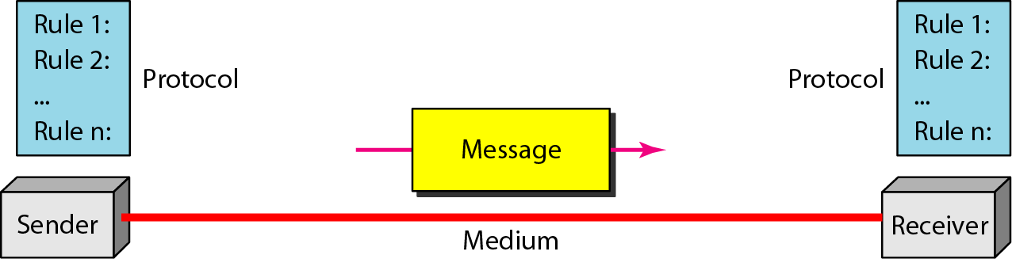
- Message: It is the information that is to be communicated.
- Sender: The sender is the device that send the message.
- Receiver: The receiver is the device that receive the message.
- Medium: The transmission medium is the physical path that communicates the message from sender to receiver.
- Protocol: It is refer to a set of rules that coordinates the exchange of information. Both sender and receiver follow the same protocol to communicate data.
ANALOG AND DIGITAL DATA TRANSMISSION
- The major role of the physical medium is to move information from one communicating device to another.
- However, information to be transmitted should be first transformed into electromagnetic signals.
- For example: You cannot just write a letter on the piece of paper, insert it into wire and transmit it across town.
- Information over medium is transmitted by two main methods: Analog and Digital.
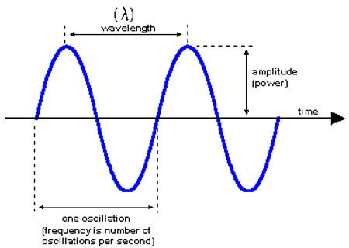
ANALOG SIGNAL
- An analog signal is a continuous waveform that changes smoothly over time.
- It is perfect for carrying data such as voice or sound.
- However, these signals are prone to error or noise, which are caused from an outside source.
- Attenuation is another problem with analog signal because the amplitude of the wave naturally change over distance.
- The sine wave is the most fundamental form of an analog signal.
- It is described by three characteristics.
- Amplitude: It is the value of the signal at any point on the wave. The maximum amplitude of a sine wave is the highest value it reaches on the vertical axis. The unit for amplitude depends on the type of the signal. For electrical signal, the unit is volts and amperes.
- Frequency: It refers to the number of cycle a signal completes in one second. In another words, frequency means the number of times a signal wave goes up and down in a second. It is measured in Hertz (Hz). For example: If a signal wave completes one cycle in a one second its frequency is one Hz.
- Wavelength: It refers to the distance between successive similar points of a given wave, means, and one cycle of the waveform.
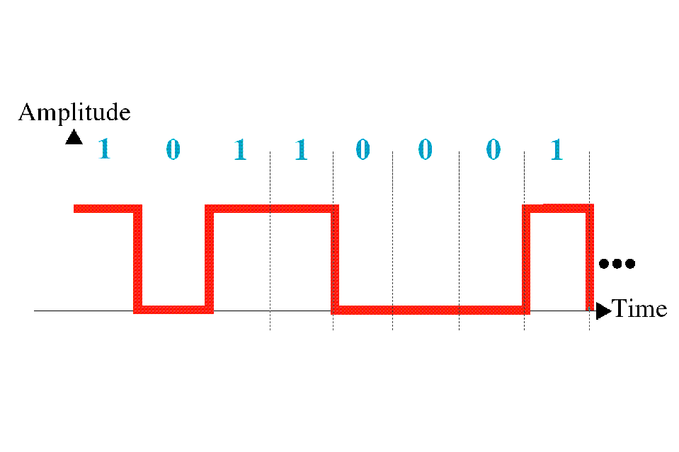
DIGITAL SIGNALL
- It is data stored in the form of “0s” and “1s”.
- When the signal is at a high point, its values is 1” and when it is low, its value is “0”.
- It is not affected by noise or attenuation as compared to the analog signals.
- It can represented by a graph similar to bar graph.
- To transmit data, over analog phone lines, a modem is required to convert digital data signals to analog signals.
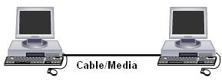
- When transmitted over long distances, analog signals require to be amplified which can possibly distort the value of the data transmitted.
NETWORK
- Definition: Interconnection of two or more computers and peripherals together via transmission media so that they can share information and resources.
- The concept of connected computers to sharing resources is called NETWORKING.
ADVANTAGES
File Sharing | - The major advantage of a computer network is that is allows file sharing and remote file access.  - A person sitting at one workstation that is connected to a network can easily see files present on another workstation, provided he is authorized to do so.  - This saves him/her the hassle of carrying a storage device every time data needs to be transported from one system to another.
Resource Sharing | - Resource sharing is another important benefit of a computer network.  - For example, if there are twelve employees in an organization, each having their own computer, they will require twelve modems and twelve printers if they want to use the resources at the same time.  - A computer network, on the other hand, provides a cheaper alternative by the provision of resource sharing.  - All the computers can be interconnected using a network, and just one modem and printer can efficiently provide the services to all twelve users.
Inexpensive Set-Up | - Shared resources mean reduction in hardware costs.  - A particular software can be installed only once on the server and made available across all connected computers at once.  - This saves the expense of buying and installing the same software as many times for as many users.
Flexible Handling | - A user can log on to a computer anywhere on the network and access his files.  - This offers flexibility to the user as to where he should be during the course of his routine.  - A network also allows the network administrator to choose which user on the network has what specific permissions to handle a file.
Increased Storage Capacity | - Since there is more than one computer on a network which can easily share files, the issue of storage capacity gets resolved to a great extent.  - A standalone computer might fall short of storage memory, but when many computers are on a network, the memory of different computers can be used in such a case.
Connectivity and Communication | - Networks connect computers and the users of those computers. Individuals within a building or work group can be connected into local area networks (LANs); LANs in distant locations can be interconnected into larger wide area networks (WANs).  - Once connected, it is possible for network users to communicate with each other using technologies such as electronic mail.  - This makes the transmission of business (or non-business) information easier, more efficient and less expensive than it would be without the network.
Internet Access Sharing | - Small computer networks allow multiple users to share a single Internet connection.  - Special hardware devices allow the bandwidth of the connection to be easily allocated to various individuals as they need it, and permit an organization to purchase one high-speed connection instead of many slower ones.
Data Security and Management | - In a business environment, a network allows the administrators to much better manage the company's critical data.  - Instead of having this data spread over hundreds of small computers data can be centralized on shared servers.  - This makes it easy for everyone to find the data, makes it possible for the administrators to ensure that the data is regularly backed up, and also allows for the implementation of security measures to control who can read or change various pieces of critical information.
DISADVANTAGES
Security Concerns | - One of the major drawbacks of computer networks is the security issues that are involved.  - If a computer is a standalone computer, physical access becomes necessary for any kind of data theft.  - However, if a computer is on a network, a hacker can get unauthorized access by using different tools.  - In case of big organizations, various network security software need to be used to prevent theft of any confidential and classified data.
Virus and Malware | - If even one computer on a network gets affected by a virus, there is a possible threat for the other systems getting affected too.  - Viruses can spread on a network easily, because of the inter-connectivity of workstations.
Lack of Robustness | - If the main file server of a computer network breaks down, the entire system becomes useless.  - If there is a central linking server or a bridging device in the network, and it fails, the entire network will come to a standstill.
Needs An Efficient Handler | - The technical skills and know-how required to operate and administer a computer network is considerably high.  - Any user with just the basic skills cannot do this job.
Lack of Independence | - Since most networks have a centralized server and dependent clients, the client users lack any freedom whatsoever.  - Centralized decision making can sometimes hinder how a client user wants to use his own computer.
Network Setup Costs | Setting up a network requires an investment in hardware and software, as well as funds for planning, designing and implementing the network.
TYPES OF NETWORK
- Networks are classified depending on the geographical area covered by the network
- There are 3 types of network
  - LAN (Local Area Network)
  - MAN (Metropolitan Area Network)
  - WAN (Wide Area Network)
1 LAN (Local Area Network)
- Privately owned and link computers and workstations covering a Small local area like, office or home ,Limited to 1.5 Km.
- Designed to allow resources to be shared between computers.
- Computers are communicated with each other using NIC (Network Interface Card) which are connected using cables and Switches.
- It enables stations to communicate directly using a common physical medium on a point to point basis.
- Depends upon application and cost, various topology used in LAN like start, bus, ring.
- It relates to a group of interlinked computers, which are positioned in a single physical location.
- It may be wired or wireless, or might employ both types of communication.
- Since all the interconnected computers and devices are placed in a single location, LAN generally allows for faster and effective data connection.
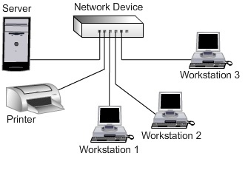
- LANs are classified depending on the techniques used for data sharing like Ethernet, Token Ring, Token Bus, FDDI
- It is identified by following properties
- Multiple system attached to shared medium
- Low error rate
- High total bandwidth upto 10 Mbps.
- Limited geography up to 2 km.
- Limited number of station.
- The Following characteristics differentiate one LAN from another
- Topology
- Protocol
- Media
Advantages of LAN:
- Improves productivity due to faster work
- Provides easy maintenance
- New systems can be installed and configured easily
- Provide Security, Hardware and software sharing.
- Access other LAN and WAN.
Disadvantages of LAN:
- Limited number of systems can only be connected
- Cannot cover large area
- Network performance degrades as number of users exceeds
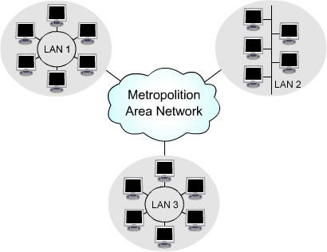
2 MAN (Metropolitan Area Network)
- It is larger than LAN and limited to city or group of nearby offices.
- So Interconnects networks within a city.It uses similar technologies of LAN. A MAN might be owned and operated by a single organization, but it usually will be used by many individuals and organizations.
- A MAN often acts as a high speed network to allow sharing of regional resources.
- A MAN typically covers an area of between 5 and 50 km diameter.
- Metro Ethernet is a service which is provided by ISPs. This service enables its users to expand their Local Area Networks.
- For example, MAN can help an organization to connect all of its offices in a city.
- Owned and Operated by private company.
3 WAN (Wide Area Network)
- It provides long distance transmission of data and voice.
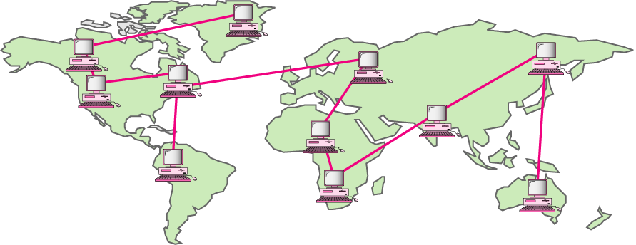
- A network that covers a wide geographical area that may comprise a country, continent or whole world is called Wide Area Network.
- Utilize public or private communication devices to span an unlimited number of miles.
- Connected by dedicated cabling or satellite links.
- LANs are interconnected using ROUTER becomes WAN.
- Another good model would be a network of a transnational company with huge offices in various regions and countries of the world.
- This type of network allows an employee of a company to easily access data and resources, which are stored on other computers in a different country.
- It can also use satellite or ground radio system. The router have antenna, through which they can send and receive data.
- It uses hierarchical addressing scheme because they facilitate routing. Addressing is required to identify which network input is to be connected to which network output.
- If WAN breaks down, there can be a stoppage in the worldwide operations of the company.
Advantages
- Provide long distance transmission
- Remotely Access data
Disadvantages
- Costly
- Complex
- Slower than LAN

DIFFERENCE BETWEEN LAN AND WAN
LAN | WAN
LAN cover less distances | WANs cover greater distances.
LAN speeds are more. | WAN speeds are slower.
LANs primarily use private network transports. | WANs can use public or private network transports
It is a group of computers in close proximity | The Internet is actually a specific type of WAN.
Easy to design and maintain. | Design and maintenance is not easy.
Transmission medium is co-axial or UTP cable. | Transmission medium is satellite link or PSTN.
It is broadcasting in nature. | IT is point to point in nature.
It operate on principal of broadcasting. | It operates on principal of point to point.

CLIENT
• Definition: A client is a piece of Computer Hardware or Software that accesses a service made available by a Server.
• Client makes a request or sending message to server.
• As Clients, they are allowed to communicate with the servers in the network in order to use the network’s resource.
• Client must install a network interface card (NIC) to talk on a network.
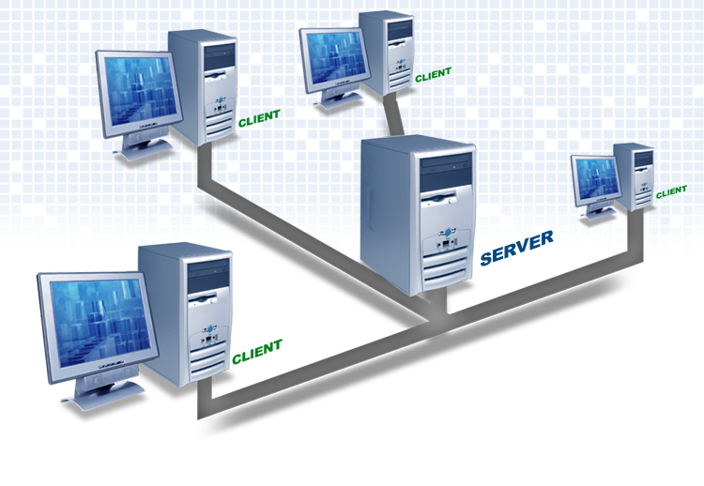
• Client may be laptop, desktop, smart cell phone, tablet, palmtop, or any software application etc.
• Rely on servers for files, Devices, Processing power
• Example: E-mail client , An application that enables you to send and receive e-mail.
SERVER
- Definition: A server is a powerful computer that provides data or services to client computers.
- It may serve data to systems on a local area network (LAN) or a wide area network (WAN) over the Internet.
- Servers come in many shapes and sizes.
- They are a core component of the network, providing a link to resources necessary to perform any task.
- Clients rely on servers for Resources, such as files, devices, and even processing power.
- Two types of Server
- Dedicated Server: These are assigned to provide specific application or services for the network.
- Non Dedicated Server:These are assigned to provide one or more network services and local access.
Various Servers
SERVER | DESCRIPTION
Web Server | - Web servers are computers that deliver Web pages.  - Every Web server has an IP address and possibly a domain name.  - For example, if you enter the URL http://www.pcwebopedia.com/index.html in your browser, this sends a request to the Web server whose domain name is pcwebopedia.com. The server then fetches the page named index.html and sends it to your browser
Database Server | - Provides database services to other computer programs or computers .  - Such a server is accessed either through a "front end" running on the user’s computer which displays requested data or the "back end" which runs on the server and handles tasks such as data analysis and storage.  - Some examples of proprietary database servers are Oracle, DB2, Informix, and Microsoft SQL Server.
Mail Server | - It handles transport of and access to e-mail.  - A mail server usually consists of a storage area where where e-mail is stored for local users, a set of user definable rules which determine how the mail server should react to the destination of a specific message, a database of user accounts that the mail server recognizes and will deal with locally, and communications modules which are the components that actually handle the transfer of messages to and from other mail servers and email clients.
File Server | - File server is a computer attached to a network that has the primary purpose of providing a location for shared disk access, i.e. shared storage of computer files (such as documents, sound files, photographs, movies, images, databases, etc.) that can be accessed by the workstations that are attached to the same computer network.  - File servers are commonly found in schools and offices, where users use a LAN to connect their client computers
Application server | - Application server is a program that handles all application operations between users and an organization  - An application server is typically used for complex transaction-based applications.

CLIENT SERVER ARCHITECTURE
- Definition: Client-server architecture can be considered as a network environment that exchanges information between a server machine and a client machine where server has some resources that can be shared by different clients.
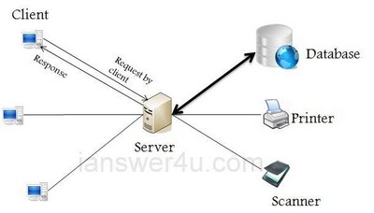
- Architecture of a computer network in which many clients (remote processors) request and receive service from a centralized server (host computer).
- In a client server network divide processing tasks between clients and servers.
- In such networks, there exists a central controller called server. A server is a specialized computer that controls the network resources and provides services to other computers in the network.
- All other computers in the network are called clients. A client computer receives the requested services from a server.
- A server performs all the major operations like security and network management.
- All the clients communicate with each other via centralized server
- If client 1 wants to send data to client 2, it first sends request to server to seek permission for it. The server then sends a signal to client 1 allowing it to initiate the communication.
- A server is also responsible for managing all the network resources such as files, directories, applications & shared devices like printer etc.
- If any of the clients wants to access these services, it first seeks permission from the server by sending a request.
- Most Local Area Networks are based on client server relationship.
Example of Client Server Architecture : When a bank customer accesses online banking services with a web browser (the client), the client initiates a request to the bank's web server. The customer's login credentials may be stored in a database, and the web server accesses the database server as a client. An application server interprets the returned data by applying the bank's business logic, and provides the output to the web server. Finally, the web server returns the result to the client web browser for display.
In each step of this sequence of client–server message exchanges, a computer processes a request and returns data. This is the request-response messaging pattern.
Advantages
- Centralization: centralized control therefore Servers help in administering the whole set-up. Access rights and resource allocation is done by Servers.
- Proper Management: All the files are stored at the same place. In this way, management of files becomes easy. Also it becomes easier to find files.
- Upgrade and Scalability: Changes can be made easily by just upgrading the server. Also new resources and systems can be added by making necessary changes in server.
- Back-up and Recovery: As all the data is stored on server its easy to make a back-up of it. Also, in case of some break-down if data is lost, it can be recovered easily and efficiently.
- Accessibility: From various platforms in the network, server can be accessed remotely.
- Security: Rules defining security and access rights can be defined at the time of set-up of server.
Disadvantage
- Congestion in Network: Too many requests from the clients may lead to congestion. Overload can lead to breaking-down of servers.
- Not Robust: if the server fails, the whole network goes down.
- Cost: It is very expensive to install and manage this type of computing.
- Need Administrator: to maintain the servers and other technical details of network.
RELATIONSHIP BETWEEN CLIENT AND SERVER
- “Client-Server” describes the relationship between two computer programs where the client makes request to the server and server provide services to the requested client.
- Client always initiate request to server and wait for replies.
- Server is a powerful computer which is always wait for request from one of the client and serve client request.
- This relationship is seen in such tasks as sending emails and accessing the web. Many business applications currently use the client-server model.
2 TIER CLIENT SERVER ARCHITECTURE
The two-tier architecture is like client server application.
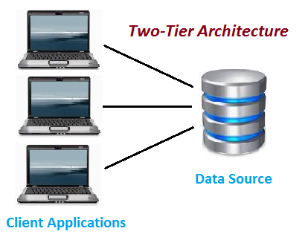
- The direct communication takes place between client and server. There is no intermediate between client and server.
- Because of tight coupling a 2 tiered application will run faster.
- The Two-tier architecture is divided into two parts:
  - Client Application (Client Tier)
  - Database (Data Tier)
- On client application side the code is written for saving the data in the SQL server database. Client sends the request to server and it process the request & send back with data.
- The main problem of two tier architecture is the server cannot respond multiple request same time, as a result it cause a data integrity issue.
Example: Let’s take a look of real life example of Railway Reservation two-tier architecture: Let’s consider that first Person is making Railway Reservation for Mumbai to Delhi by Mumbai Express at Counter No. 1 and at same time second Person is also try to make Railway reservation of Mumbai to Delhi from Counter No. 2.If staff from Counter No. 1 is searching for availability into system & at the same staff from Counter No. 2 is also looking for availability of ticket for same day then in this case there is might be good change of confusion and chaos occurs. There might be chance of lock the Railway reservation that reserves the first.
- But reservations can be making anywhere from the India, then how it is handled?
- So here if there is difference of micro seconds for making reservation by staff from Counter No. 1 & 2 then second request is added into queue. So in this case the Staff is entering data to Client Application and reservation request is sent to the database. The database sends back the information/data to the client.
- In this application the Staff user is an end user who is using Railway reservation application software. He gives inputs to the application software and it sends requests to Server. So here both Database and Server are incorporated with each other, so this technology is called as “Client-Server Technology“.
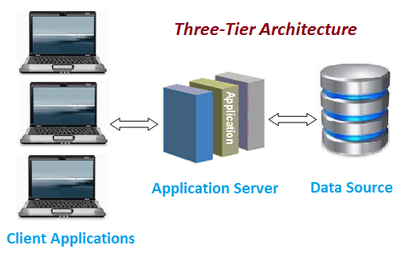
3 TIER CLIENT SERVER ARCHITECTURE
- Three-tier architecture typically comprise a presentation tier, a business or data access tier, and a data tier.
- Three layers in the three tier architecture are as follows:
    - Client layer
    - Business layer
    - Data layer
Client layer: It is also called as Presentation layer which contains UI part of our application.
- This layer is used for the design purpose where data is presented to the user or input is taken from the user. For example designing registration form which contains text box, label, button etc.
Business layer:
- In this layer all business logic written like validation of data, calculations, data insertion etc.
- This acts as a interface between Client layer and Data Access Layer. This layer is also called the intermediary layer helps to make communication faster between client and data layer.
Data layer:
- In this layer actual database is comes in the picture.
- Data Access Layer contains methods to connect with database and to perform insert, update, delete, get data from database based on our input data.
Advantages
- High performance, lightweight persistent objects
- Scalability – Each tier can scale horizontally
- Performance – Because the Presentation tier can cache requests, network utilization is minimized, and the load is reduced on the Application and Data tiers.
- High degree of flexibility in deployment platform and configuration
- Better Re-use
- Improve Data Integrity
- Improved Security – Client is not direct access to database.
- Easy to maintain and modification is bit easy, won’t affect other modules
- In three tier architecture application performance is good.
Disadvantages
Increase Complexity/Effort
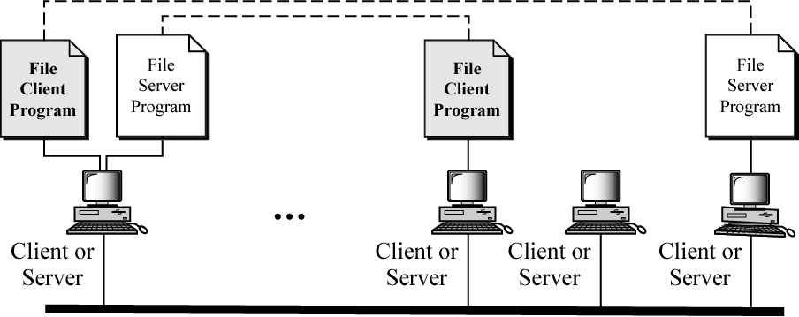
PEER TO PEER NETWORK
- On a peer-to-peer network, every computer is equal and can communicate with any other computer on the network to which it has been granted access rights.

- Essentially, every computer on a peer-to-peer network can function as both a server and a client. Any computer on a peer-to-peer network is considered a server if it shares a printer, a folder, a drive, or some other resource with the rest of the network. This is why you might hear about client and server activities, even when the discussion is about a peer-to-peer network.
- Peer-to-peer networks can be as small as two computers or as large as hundreds of systems and devices. Although there is no theoretical limit to the size of a peer-to-peer network, performance, security, and access become a major headache on peer-based networks as the number of computers increases.
- The upper limit of the number of nodes that can function as both clients and servers on a peer to peer network is between 10 to 25.
- It is primarily designes for small to medium LAN.

Advantages
- Cost: cheaper than server network. Provide cost effective way for networking upto 10 PC.
- Small Network: ideal for small network.
- Easily Configure: There is no server so no need require expert to configure this type of network.
Disadvantages
- Performance: Performance is affected as all of the machine are of lower configuration than dedicated server.
- Security: Security available in server based network is not available here.
- Decentralized: No central repository.
- Scalability: Cannot be used for network that span long distance.

DIFFERENCE BETWEEN PEER 2 PEER NETWORK Vs CLIENT SERVER
Criteria | Peer-to-Peer Networks | Client/Server Networks
Centralised | No central repository for files and applications. | Resources and data security are controlled through the server.
Maintenance | Low maintenance cost. | A large network require extra staff to ensure efficient operation.
Installation | Can be easily installed. | Require expert for proper installation of the network.
Expensive | No need for dedicated server. | Expensive as it require dedicated server.
Security | Lack of proper security policy is the biggest drawback. | Provides high level of security.
Dependence | All nodes are independent of each other. Failure occurring in one node doesn’t affect the functioning of the other nodes in the network. | When server goes down, it affects functioning of the entire network.
Operating System | Can operate on a basic PC operating system | Need a special operating system
Performance | Performance is low because server often act as a workstation. | Performance is high because server is dedicated and doesn’t handle other task.

DATA FLOW
- Data communications are the exchange of data between two devices via some form of transmission medium such as a wire cable.
- Data blow between two devices can be
      - Simplex
      - Half Duplex
      - Full Duplex
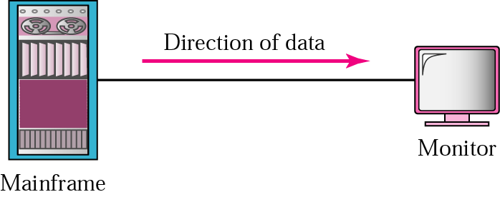
- SIMPLEX
- The communication is unidirectional, as on a one-way street.
- Only one of the two devices on a link can transmit; the other can only receive.
- The simplex mode can use the entire capacity of the channel to send data in one direction.
- Example: Keyboards and traditional monitors are examples of simplex devices. Also data sent to printer is also example of simplex data flow.
2 HALF DUPLEX
- Each station can both transmit and receive, but not at the same time. When one device is sending, the other can only receive, and vice versa.
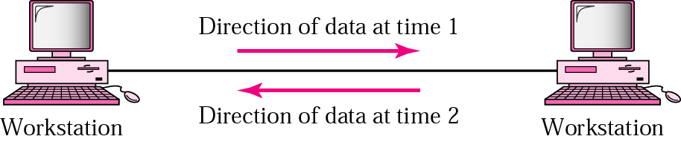
- The half-duplex mode is like a one-lane road with traffic allowed in both directions.
- The half-duplex mode is used in cases where there is no need for communication in both directions at the same time.
- The entire capacity of the channel can be utilized for each direction
- Example: Walkie-talkies.
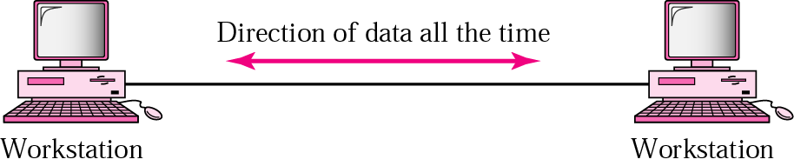
- FULL DUPLEX
- In full-duplex mode (also called duplex), both stations can transmit and receive simultaneously
- The full-duplex mode is like a Two-way street with traffic flowing in both directions at the same time.
- In full-duplex mode, signals going in one direction share the capacity of the link: with signals going in the other direction.
- Example: Telephone, mobile Communication.
DIFFERENCE BETWEEN INTERNET, INTRANET AND EXTRANET
Internet:This is the world-wide network of computers accessible to anyone who knows their Internet Protocol (IP) address.
Intranet: Intranet is an internal private computer network or connection of one or more computer networks, whose use and access is restricted to an organization and its employees or members.These kinds of networks are used for ease of information sharing and communication in companies. In industries, based on the information technology, intranets are absolutely necessary, as their work involves a high degree of data sharing and collaboration among computer users.
Extranet:An extranet is a private network that uses Internet protocols, network connectivity. An extranet can be viewed as part of a company's intranet that is extended to users outside the company, usually via the Internet.

NIC
- Component which is responsible for physically connecting the computer to the transmission media.
- Responsible for moving data from the computer to the network and vice versa.
- Manage the communication and network protocol for pc.
- Support Ethernet, token ring and FDDI
- Also Known as Network card or Transceiver.
NIC Components
- Expansion bus connector : Act as connection medium to system board.
- Media Connector : Connection medium to transmission medium.
- Buffer : Used to store data before processing so that NIC can handle bottleneck on network.
- Transceiver : Responsible for converting the sent and received data
Function of NIC
- To transmit and receive data to and from the network.
- Follow below step when it send data on network.
- The system send data in parallel format to the NIC through system expansion bus.
- NIC place data in buffer, where it can be stored if NIC cannot process data quickly.
- Transceiver convert the format of the data signal from parallel format to serial format so that it can be sent over the network.
- Media connector which physically join the network card to the transmission media, send the data on to the network.
- Receive incoming data from the cable and translate it into bytes that can be understood by CPU

MAC (MEDIA ACCESS CONTROL)
- NIC have unique hardware or physical address or Ethernet Address.
- It is 48 bit address display as 12 digit hexadecimal address.
- Assigned by the manufacturer of a NIC.
- Stored in its hardware, such as the card's ROM or some other firmware.
- Used by NIC to address data to other NIC and recognize data sent for it.
- Also known as hardware or physical address
- Used to identify nodes at lower levels of the OSI model
- ID assigned by IEEE
- Hardware address hard-coded into NIC
- Nodes on network identified by MAC address
- Work at Data Link Layer.
- It is Fix, It can not be changed.
- For Example : 00:A0:C9:14:C8:29
- First half of MAC Address contain the ID number of the adapter manufacturer. These IDs are regulated by an Internet standards body.
- Here: 00:A0:C9 ----- indicate the manufacture is intel corporation.
- Second half of MAC Address represents the serial number assigned to the adapter by the manufacturer.

